**Office Supplies Business Performance Analysis Report**

**Date: May 7, 2025**

**Executive Summary**

This report presents key findings from our comprehensive data analysis of sales, profitability, and operational performance. The analysis reveals opportunities for growth in specific regions and customer segments, identifies products requiring pricing strategy adjustments, and provides recommendations for optimizing discount strategies and shipping operations.

**1. Sales & Profitability Analysis**

**Key Findings:**

* **Top Revenue/Profit Drivers:** Office supplies categories generate the highest revenue and profit, followed by the technology category.
* **Underperforming Products:** Several products consistently sell at a loss, including Tables, Rubber bands, Scissors, Rulers, Trimmers, Envelopes, and Bookcases.

**Visualization Opportunities:**

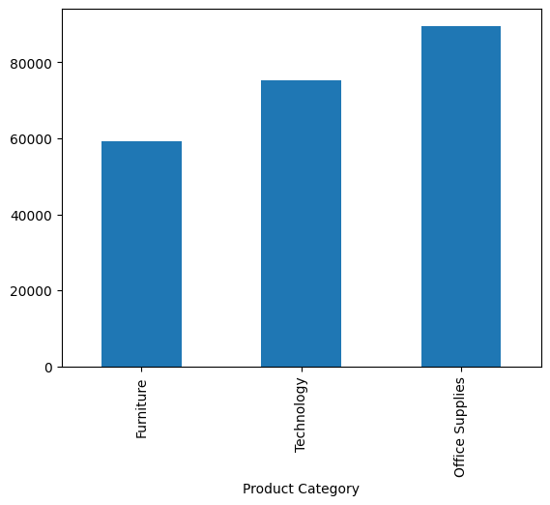

Product Category Revenue Comparison

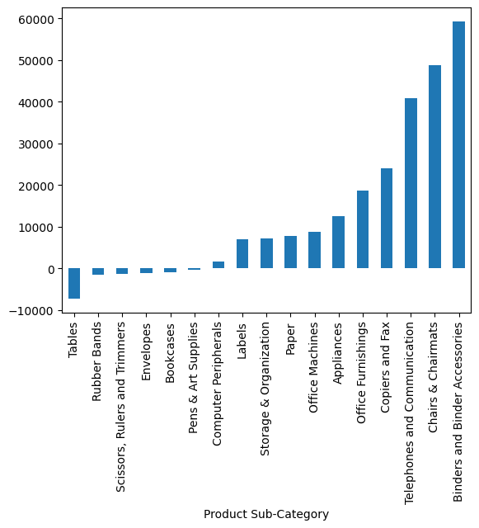

Profit Margins by Product Category and loss-Making Products

**Recommendations:**

* Continue investing in marketing and inventory for office supplies categories
* Consider product redesign or supplier renegotiation for underperforming items
* Implement targeted repricing strategy for loss-making products before considering discontinuation

**2. Discount Strategy Evaluation**

**Key Findings:**

* **Discount Impact:** Poor correlation between discounts and both profits and sales
* **Optimal Discount Rate:** 5% maximizes both sales and profit metrics

**Visualization Opportunities:**

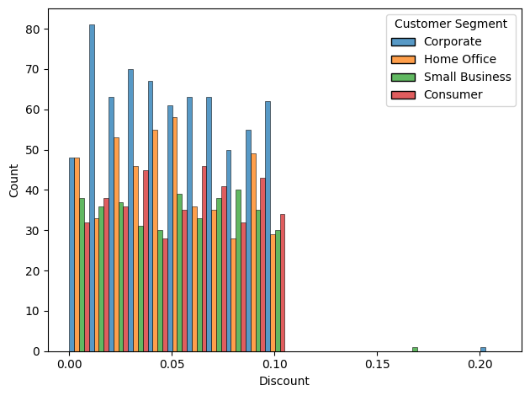

Sales Performance Across Different Discount Tiers

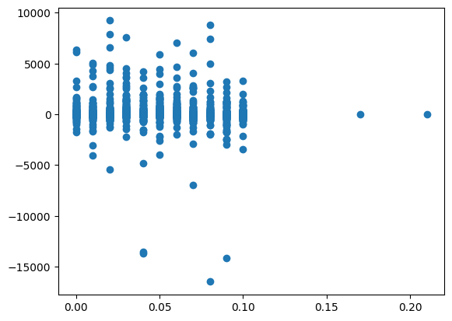

Insert Chart: Discount Rate vs. Profit Correlation

**Recommendations:**

* Standardize discount offerings around the 5% optimal rate
* Implement A/B testing for discount strategies in different regions
* Develop a more sophisticated discount framework based on product category and customer segment

**3. Shipping & Logistics Optimization**

**Key Findings:**

* **Processing Time:** Order processing time is consistent across all shipping methods
* **Cost Reduction:** Regular Air and Express Air offer cost advantages over delivery trucks in certain scenarios

**Visualization Opportunities:**

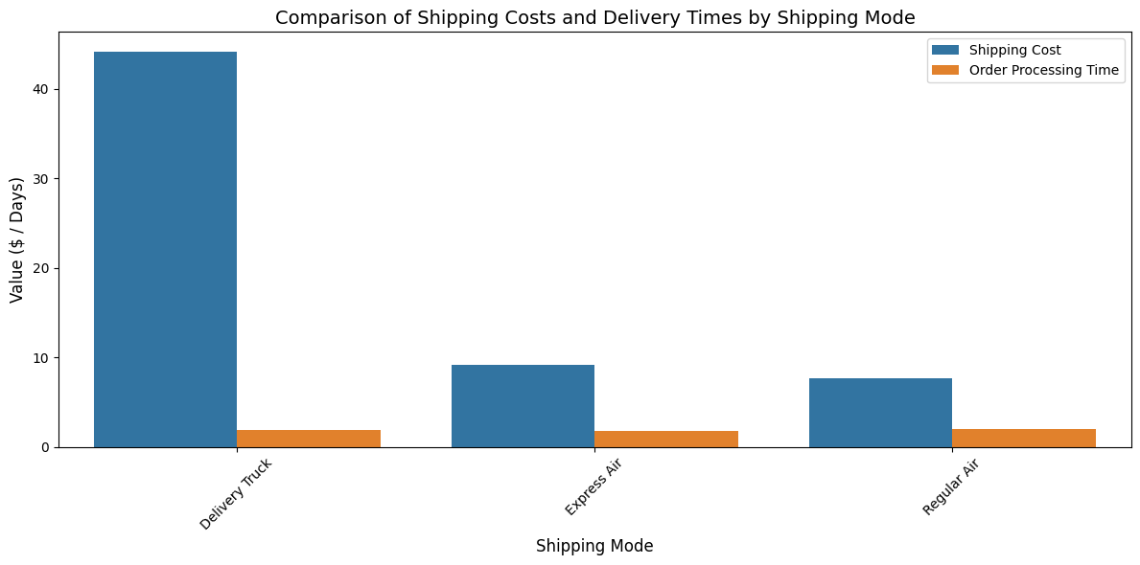

Shipping Method Cost Comparison

* [Insert Chart: Delivery Time Analysis by Shipping Method]
* [Insert Chart: Regional Shipping Cost Variations]

**Recommendations:**

* Prioritize Regular Air and Express Air over delivery trucks only where feasible and where a better result will be noticeable
* Negotiate improved rates with current shipping partners
* Consider regional shipping hubs to reduce delivery times and costs. This is because Delivery Trucks which provide the fastest delivery time in the US will work better with Regional hubs

**4. Regional Performance Insights**

**Key Findings:**

* **Growth Regions:** Eastern and Western regions show strong demand and growth potential
* **Declining Markets:** States and cities in the South and Central regions exhibit declining demand

**Visualization Opportunities:**

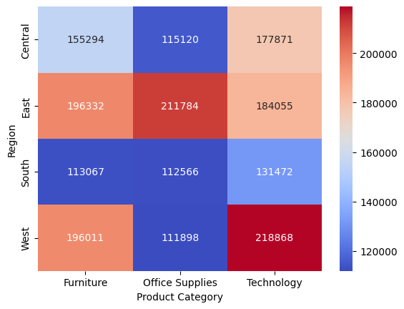

Regional Sales Performance Heatmap

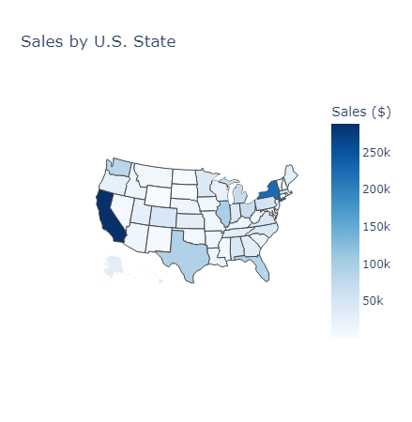

Market Share Distribution Across Regions

**Recommendations:**

* Allocate additional marketing resources to Eastern and Western regions, especially where there is evident increase in sales like New York (East) and California (West)
* Conduct market research in declining regions to identify root causes
* Develop region-specific product offerings based on local preferences

**5. Customer Segmentation Analysis**

**Key Findings:**

* **High-Value Segments:** Corporate and Home Office segments demonstrate the highest value
* **Segment Behavior Differences:** [Space for additional insights on behavioral differences]

**Visualization Opportunities:**

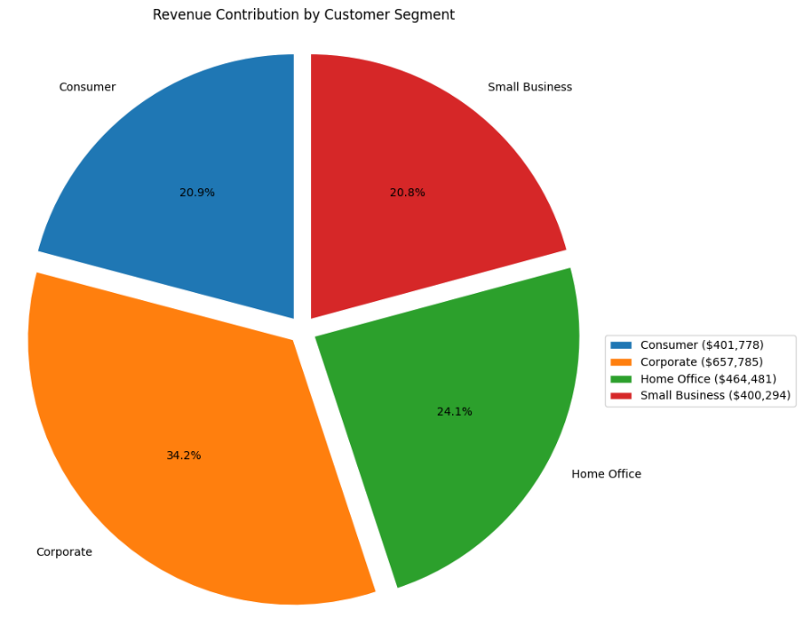

Customer Segment Revenue Comparison

* [Insert Chart: Purchasing Patterns by Customer Segment]
* [Insert Chart: Lifetime Value Analysis by Segment]

**Recommendations:**

* Develop targeted marketing campaigns for Corporate and Home Office segments
* Create loyalty programs specifically designed for high-value customer segments
* Implement personalized pricing strategies based on segment purchasing behaviors

**6. Conclusion & Next Steps**

This analysis highlights several opportunities for immediate business improvement. Key recommendations include:

1. **Product Portfolio Optimization:** Address loss-making products through repricing or discontinuation
2. **Discount Strategy Refinement:** Implement the optimal 5% discount rate while testing segment-specific variations
3. **Shipping Method Adjustment:** Shift toward Regular Air and Express Air options where cost-effective
4. **Regional Focus:** Concentrate expansion efforts on Eastern and Western regions
5. **Customer Targeting:** Prioritize Corporate and Home Office segments for marketing investments

**Proposed Timeline for Implementation:**

* Immediate (1-2 months): Discount rate standardization and loss-making product repricing
* Short-term (3-6 months): Regional marketing reallocation and shipping method optimization
* Long-term (6-12 months): Comprehensive customer segmentation strategy implementation